**PYTHON PROGRAMMING**

**Assignment # 02**

**Submitted By: Maria Farooq**

**Question 01**

Write a Python program that:

1. Accepts a string, an integer, a float, and a boolean from the user.

2. Initializes variables for each type, and prints them out.

3. Convert the string to uppercase and print it.

4. Check if the integer is even or odd and print the result.

5. Multiply the float by 2 and print the result.

#For String

user_input_string = input("Enter a string: ")

user_input_integer = int(input("Enter an Integer: "))

user_input_bool = bool(input("Enter a bool Value (True/False): "))

user_input_float = float(input("Enter a float: "))

print("Given string:" , user_input_string)

print("Given Integer Value:" , user_input_integer)

print("Given Boolean Value:" , user_input_bool)

print("Given Float Value:" , user_input_float)

#Converting it to uppercase

print("Given string in uppercase:" , user_input_string.upper())

# -------------------- For Integer -------------------------

def number_check(number):

    if number % 2 == 0:

        print(f"The number you have entered: {number} is an even number.")

    else:

        print(f"The number you have entered: {number} is an odd number."

number_check(user_input_integer)

# ---------------------------- For Float ---------------------------

def float_multiply(num):

    return num*2

print("New float Value: " , float_multiply(user_input_float))

**Output**

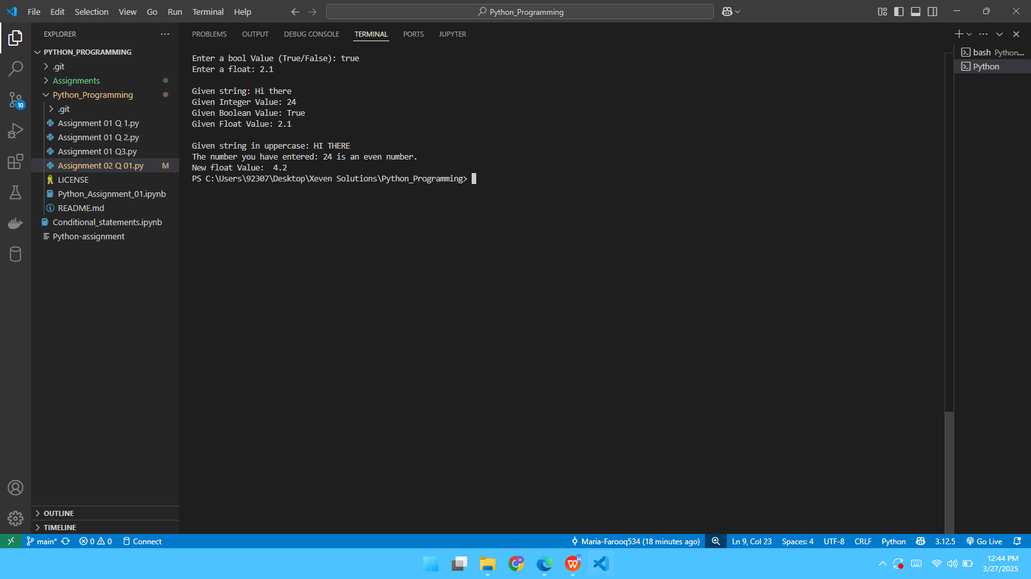

**Question 02**

**Question 03**

**Question 04**